CO1 ASSESSMENT TOOL
OUTPUT PREDICTION

NAME: R. JANANI SRI
REGISTER NUMBER: 192511093
COURSE: DATA STRUCTURES
CODE: CSA-0307

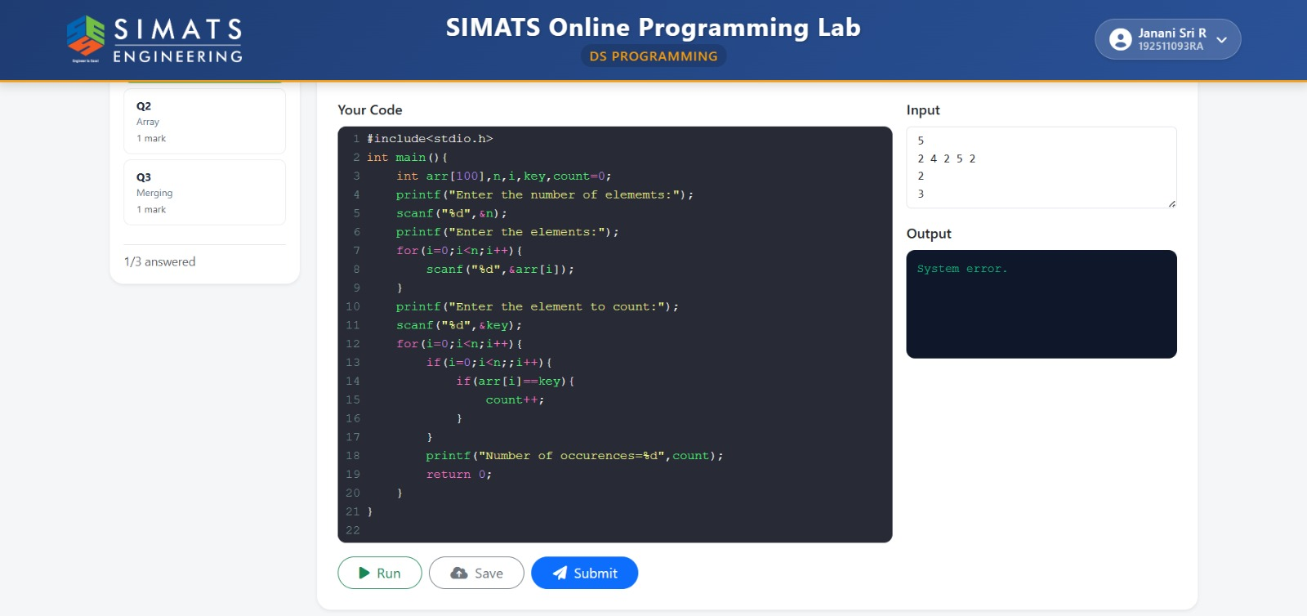
- C program to count the number of occurrences

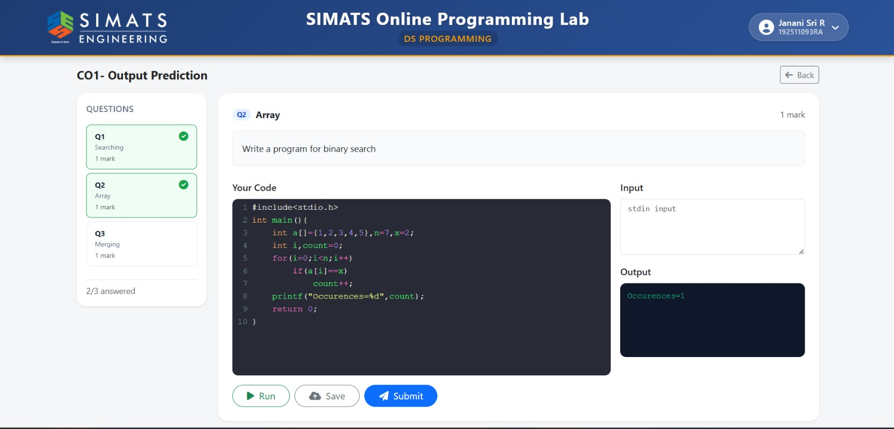
- C program for binary search

- C program to merge two arrays

